**Introduction to Jupiter**

**Lab report #01**



Fall 2022

CSE-408L Data Analytics

Submitted by: **Ashfaq Ahmad**

Registration No: **19PWCSE1795**

Class Section: **B**

“On my honor, as student of University of Engineering and Technology, I have neither given nor received unauthorized assistance on this academic work.”

Student Signature: ______________

Submitted to:

**Eng: Faizullah**

**Oct** 30, 2022

**Department of Computer Systems Engineering**

**University of Engineering and Technology, Peshawar**

**Task 00:**

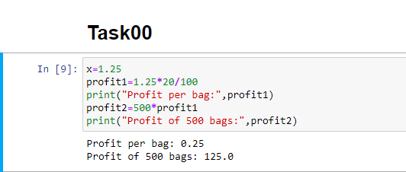

**Task 01:** The population of a town is 198568. Out of them 45312 are men and 35678 are women. Find the number of children in the town.

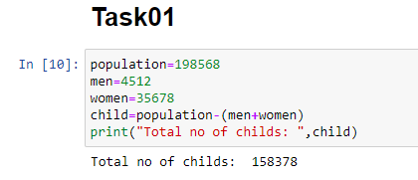

**Task 02:** A shopkeeper has 2425 boxes of 24 pencils each. How many pencils do all the boxes have in all?

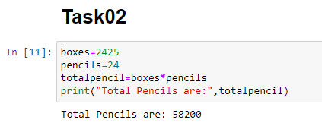

**Task 03:** Linda bought a coat for $2265 and a sari for $2150. She gave $5000 to the shopkeeper. How much money did the shopkeeper return to her?

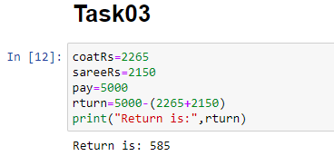

**Task 04:** The cost of 21 TV sets is $95844. Find the cost of one TV set.

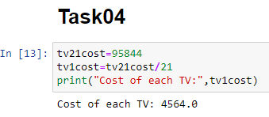

**Task 05:** A factory produces 24532 bulbs in a month. What is its annual production?

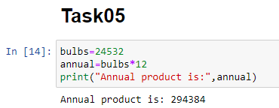

**Task 06:** There are 145968 bags of sugar, 236487 bags of wheat and some bags of rice in a go down. If the total number of bags in the go down is 450000, find the number of bags of rice.

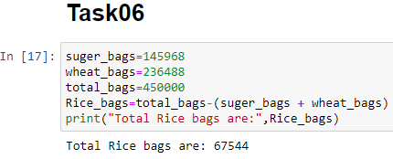

**Task 07:** A factory manufactured 483685 toys in three weeks. The production in first week was 146345 toys and in second week 138152 toys. Find the production in the third week.

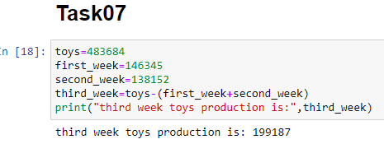

**Task 08:** The cost of a sofa set is $9372. How much wills 124 such sofa sets cost?

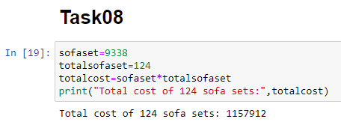

**Task 09:** There are 86 rooms in a school. 4386 students study there. Find Equal number of students sits in each room?

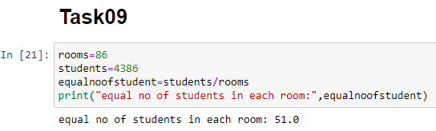

**Task 10:** 1575 students of a school want to go Hayatabad by bus. If one bus can carry 75 students, how many buses are required to carry all the students?

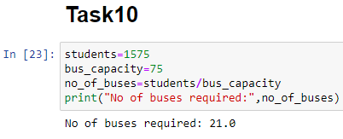

**Task 11:** The cost of a radio set is 1475. What is the cost of 35 such radio sets?

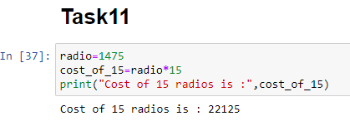

**Task 12:** In an election, 52496 people voted for Ron, 44929 people for Jhon and 36824 people for Mike in a town. If everyone voted in the town, what is the total number of voters?

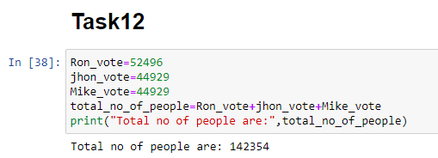

**Task 13:** Maria bought 96 toys priced equally for $12960. The amount of $1015 is still left with her. Find the cost of each toy and the amount she had.

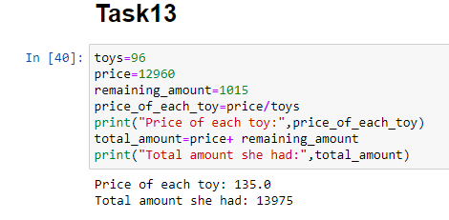

**Task 14:** A travel company wants to fly a plane to the Karachi. Flying the plane costs 5000 dollars. So far, 29 people have signed up for the trip. If the company charges 200 dollars per ticket, what is the profit made by the company? Create variables for each numeric quantity and use appropriate arithmetic operations.

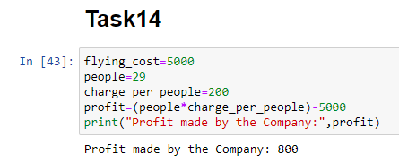

**Task 15:** Calculate and display the sum of all the numbers divisible by 7 between 18 and 534

I.e. 21+28+35+...+525+532

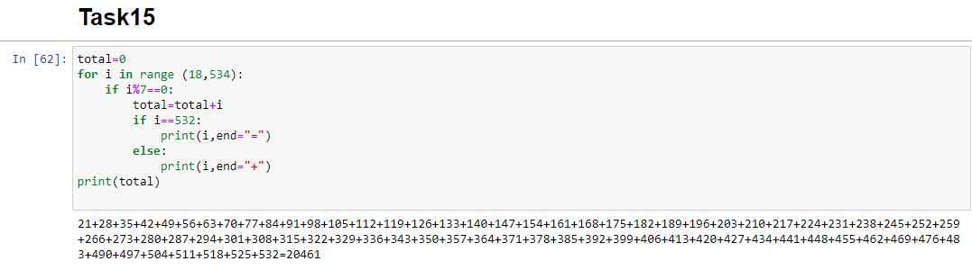

**Task 16:** Are you ready to perform some Data Analysis with Python ? In this problem, we'll analyze some fictional tweets and find out whether the overall sentiment of Twitter users is happy or sad. This is a simplified version of an important real world problem called sentiment analysis. Before we begin, we need a list of tweets to analyze. We're picking a small number of tweets here, but the exact same analysis can also be done for thousands, or even millions of tweets. The collection of data that we perform analysis on is often called a dataset.

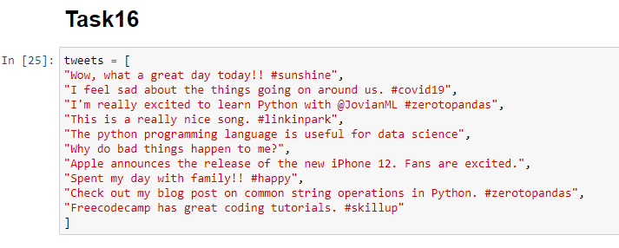

1. **How many tweets does the dataset contain?**

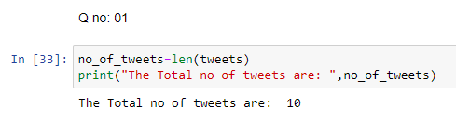

1. **Determine the number of tweets in the dataset that can be classified as happy**

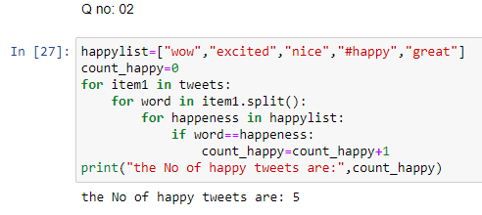

1. **What fraction of the total number of tweets is happy?**

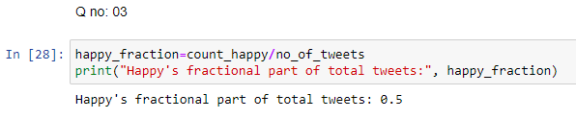

1. **Determine the number of tweets in the dataset that can be classified as sad**

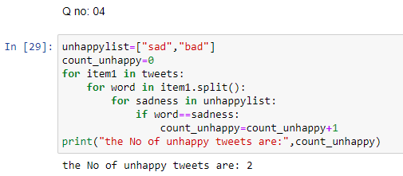

1. **What fraction of the total number of tweets is sad?**

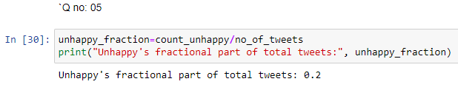

1. **Calculate the sentiment score, which is defined as the difference between the fraction of happy tweets and the fraction of sad tweets. Display whether the overall sentiment of the given dataset of tweets is happy or sad, using the sentiment score.**

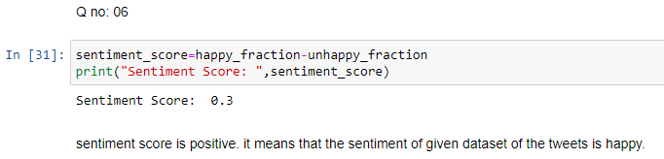

1. **Determine the number of tweets in the dataset that can be classified as neutral.**

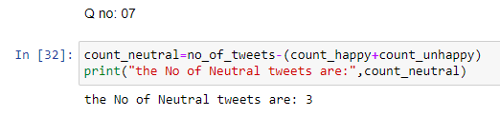

1. **What is the fraction of tweets that are neutral i.e. neither happy nor sad**

